Introduction
Large organisations such as Banks and Fintechs depend highly on technology infrastructure that must always be available and running 24/7. When a service fails, the incident is recorded into an IT Service Management (ITSM) platform (e.g. ServiceNow) and managed by ITIL practices (Axelos, 2019). Each incident receives a priority from P1 (critical) to P4 (low), based on its impact and urgency, and must be resolved within a Service Level Agreement (SLA).
In Financial Services, incident management is heavily measured in regulatory. The EU Digital Operational Resilience Act (DORA), active since January 2025, requires companies to classify and report major Technology-related incidents (European Union, 2022), and the Central Bank of Ireland expects companies to stay within an impact threshold for important business services (Central Bank of Ireland, 2021). Reliable IT operations therefore support both competitive advantage (Porter and Millar, 1985) and regulatory.
AIOps, the use of machine learning on IT operations data, was created to help organisations detect, prioritise and prevent failures (Dang, Lin and Huang, 2019; Notaro, Cardoso and Gerndt, 2021). This project applies these ideas to a public ServiceNow incident dataset to give service-management analysts information on which incidents are likely to miss their SLA targets.
Problem Definition
Large companies open thousands of incidents every month, and their database history can surpass a million records. Three issues limit the value of this data. First, priority is set manually and is often too high or too low, so urgent incidents may wait while minor ones are escalated. Second, records are often incomplete or highly technical, so analysts must read them one by one to categorise them, which is not feasible at this volume. Third, SLA breaches are identified only after, when the impact has already happened. A case study at ING, a large European bank, reported similar challenges, including poor data quality and the need for incident clustering (Kapel et al., 2024).
The result is longer disruptions of service, wasted time, weaker reporting and higher exposure. Predictive analytics can help in three ways: a model can estimate how likely an Incident is to breach its SLA first thing when it’s logged, so teams can act early; statistical tests can show if the assigned priorities match the outcomes; and clustering can group incidents into recurring patterns without manual work by the Analyst. Previous studies show that incident time can be predicted from ticket attributes (Amaral et al., 2019) and that machine learning outperformed rule-based risk scoring in a regulated bank (Kapel et al., 2026).
Aim and Objectives
Aim: to develop a machine learning model and dashboard that identify, when an incident is logged, which incidents are likely to breach their SLA and which applications, categories and locations concentrate the risk.
Hypothesis: H1 – a model using only information available when an incident is opened predicts SLA breach significantly better than a baseline using priority alone. H0 – there is no significant difference.
Objectives:
- By the end of Semester 1, transform the csv file into an incident dataset of at least 20,000 records, using only data known at opening to avoid data leakage.
- By Semester 2, test if the assigned priority is associated with SLA outcome and resolution time using chi-square and Kruskal–Wallis tests.
- By mid-Semester 2, compare at least three classifiers, aiming for a ROC-AUC of at least 0.75 on a time-based test set, and explain predictions with SHAP values (Lundberg and Lee, 2017).
- By mid-Semester 2, cluster incidents into groups and rank hotspots by volume and breach rate.
- Business objective: by end-Semester 2, deliver a Power BI dashboard that lets an analyst monitor risk, hotspots and trends, evaluated against a requirements checklist.

Scope
In scope:
- Incident records from the UCI ServiceNow event log (March 2016 to February 2017).
- SLA-breach prediction (classification) as the core model.
- Statistical testing of priority consistency.
- Clustering and hotspot analysis by category, subcategory, symptom, location and assignment group.
- Trend analysis of incident volumes, a Power BI dashboard and a GitHub repository.
Out of scope:
- Employer and other confidential data.
- Free-text analysis, as the dataset does not contain incident descriptions.
- Real-time integration with ServiceNow, production deployment and regulatory reporting.
Stretch goal: if necessary, the BPI Challenge 2014 dataset will be used to analyse incidents linked to changes and configuration items, which the UCI data records includes on fewer than 1% of incidents.

Methodology
The project will follow CRISP-DM (Cross-Industry Standard Process for Data Mining), which moves through business understanding, data understanding, data preparation, modelling, evaluation and deployment (Chapman et al., 2000). It suits this project because it starts from the business question and allows each phase to be revisited if any issues appear during the development.
Data preparation. The UCI file is an event log with one row per update. It will be reshaped into one row per incident: information will come from the first event and the target, SLA met or breached, from the last event. Incidents missing important fields will be removed, while gaps in less important fields, such as symptom, will be labelled as “Unknown”.
Modelling and evaluation. Classification models such as logistic regression, decision trees and random forests will be trained to predict SLA breach and compared with a simple baseline that uses priority alone. Data will be split by time, training on earlier months and testing on later ones, to reflect a real scenario. Models will be evaluated with accuracy, precision, recall and F1. A chi-square test will check whether priority is associated with SLA outcome, and clustering (e.g. k-means) will group similar incidents to identify hotspots.
Tools. Python (pandas, scikit-learn, seaborn) will be used for analysis and modelling, SQLite for storage, Power BI for the dashboard and GitHub for version control. Open-source tools were chosen for modelling because they are free, transparent and reproducible; Power BI is extensively used for reporting in financial services.
Architecture. Figure 1 shows the data flow: source files are loaded into SQLite, prepared in Python and passed to three analytical streams. Results are evaluated and written back as scored tables that feed the dashboard, with governance controls applied throughout.
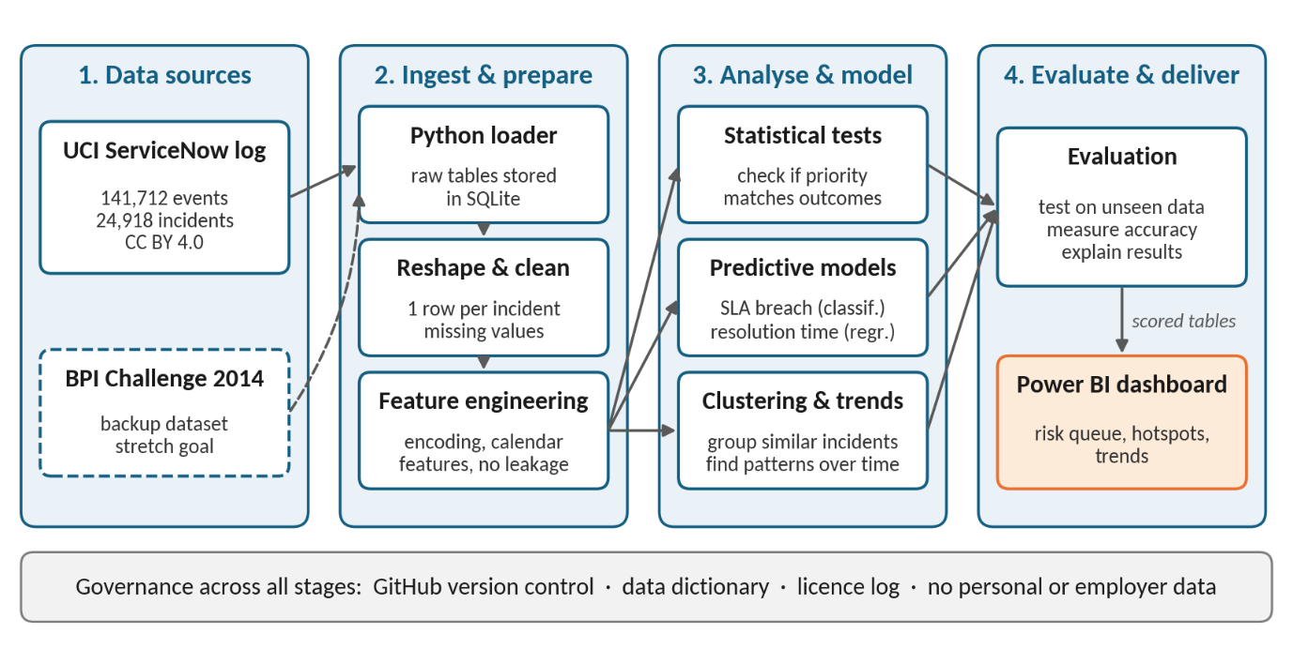
Figure 1. High-level architecture of the proposed solution.

